Scenario 1: Global Enterprise Baseline & Universal Journal

- OX15 – CREATE COMPANY
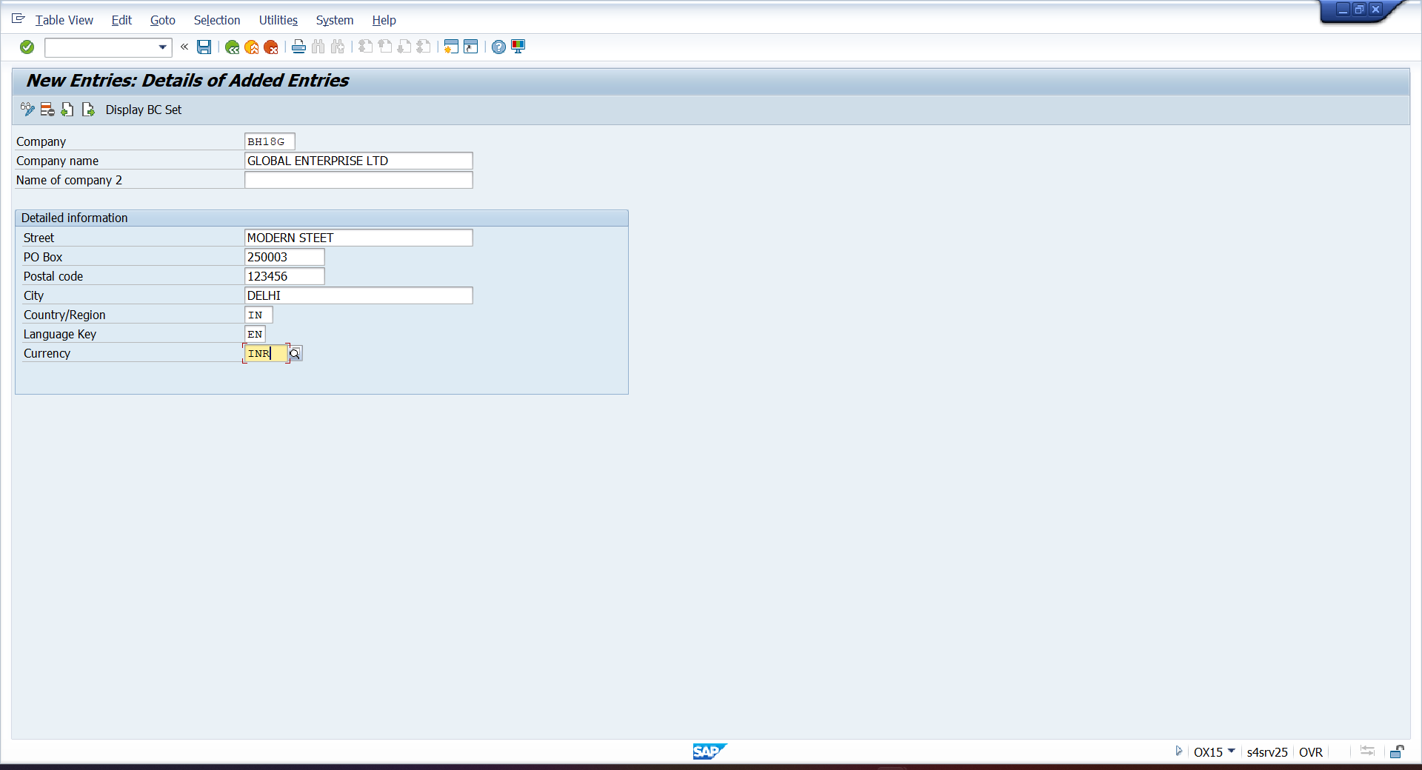

- OX02- CREATE COMPANY CODE
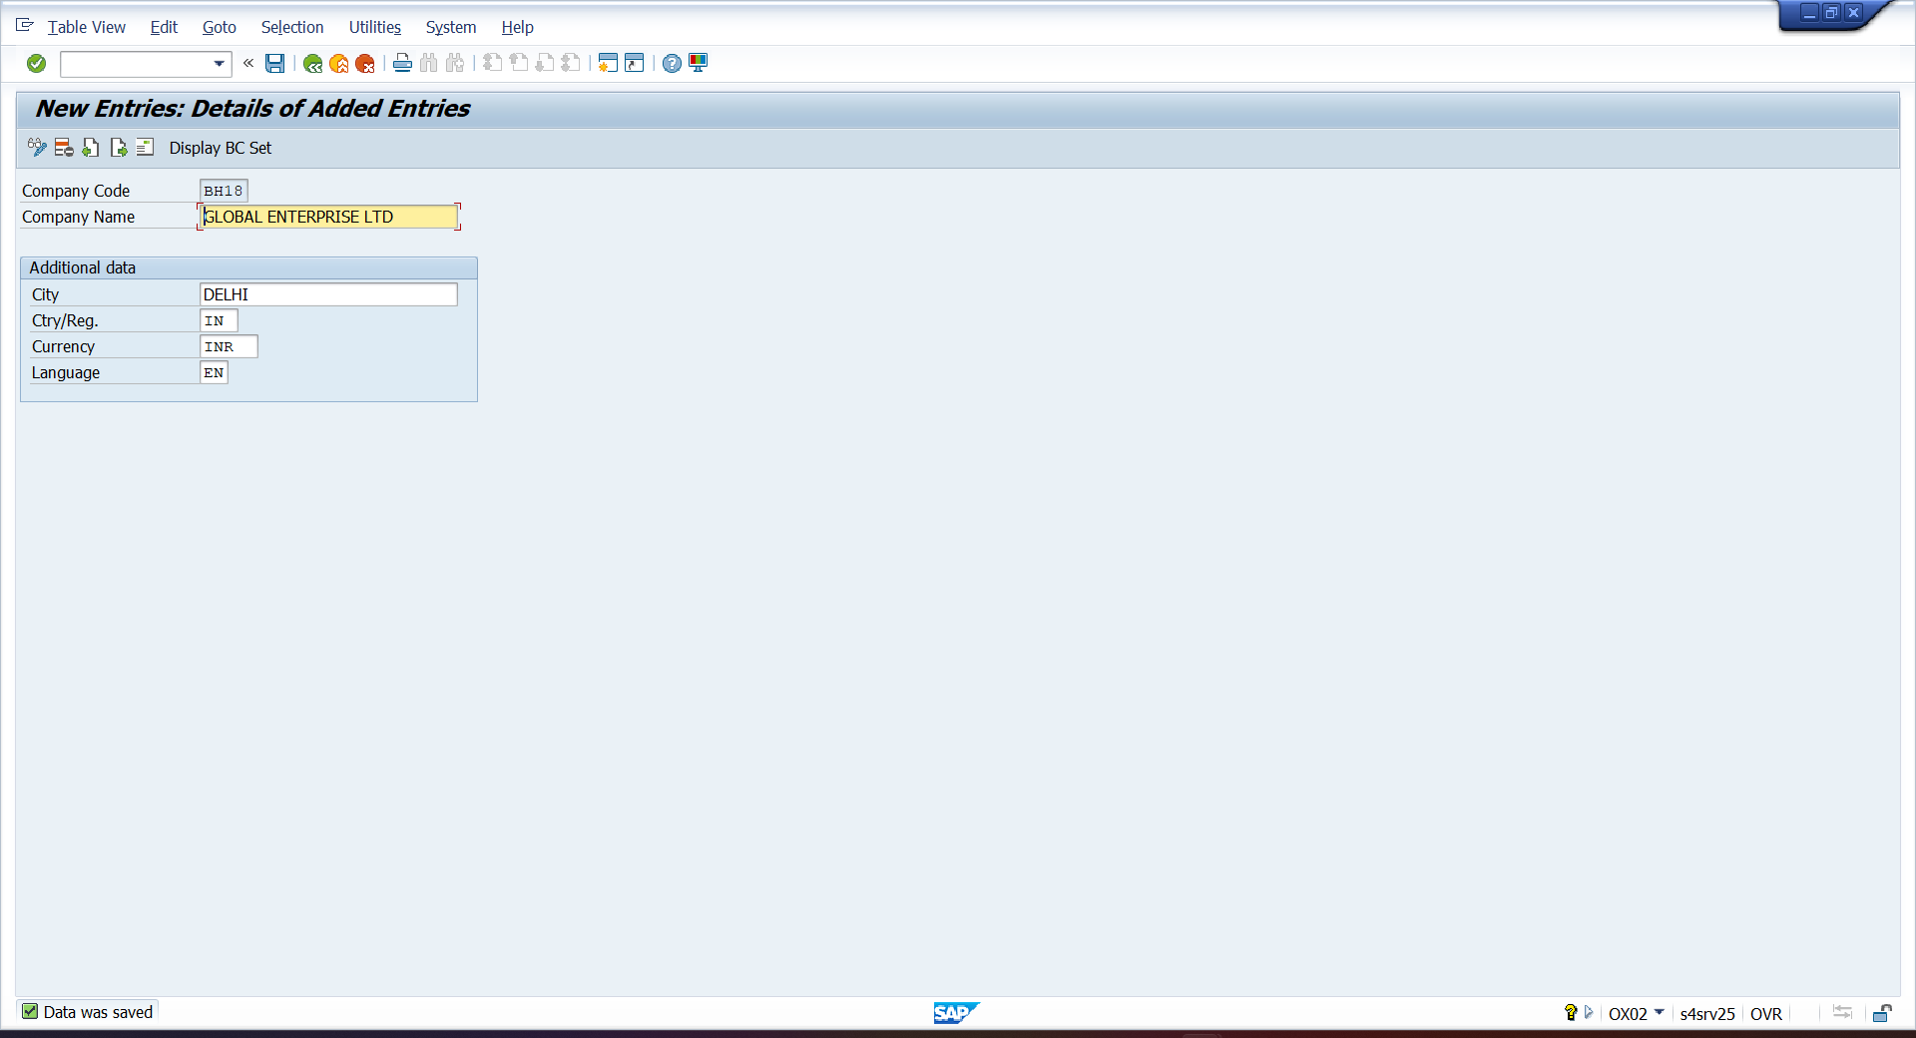

- OX16 – ASSIGN COMPANY CODE
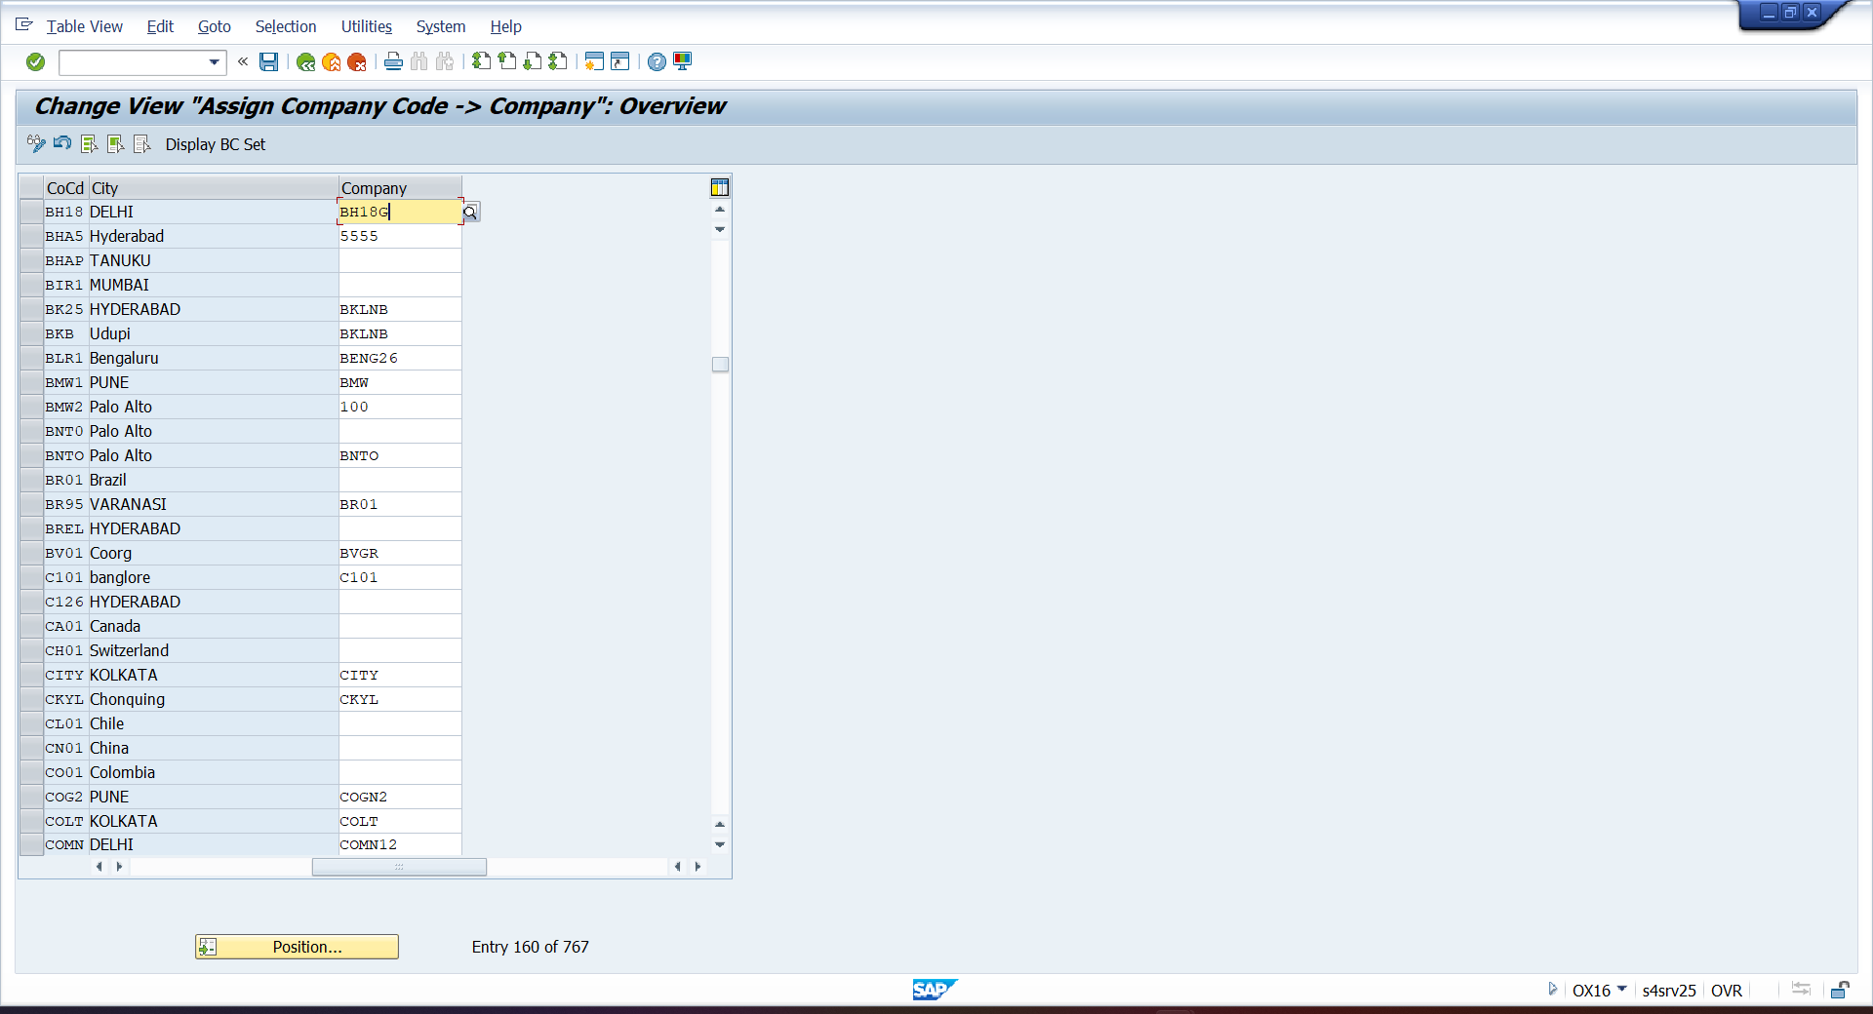

- OX37 – ASSIGN FISCAL YEAR VARIENT
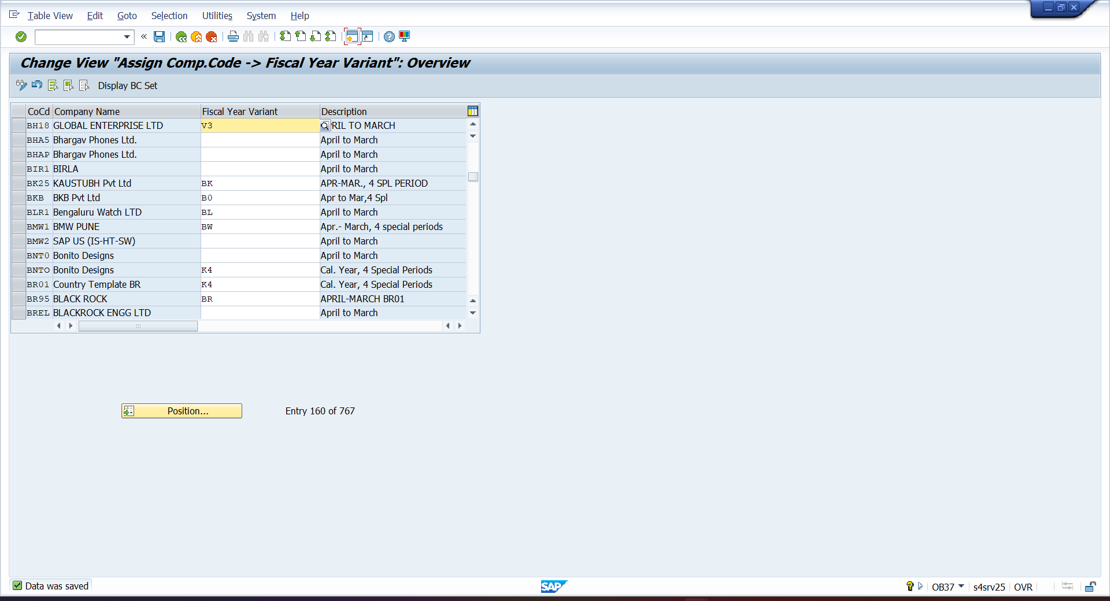
- OBBO – CREATE POST PERIOD VARIENT
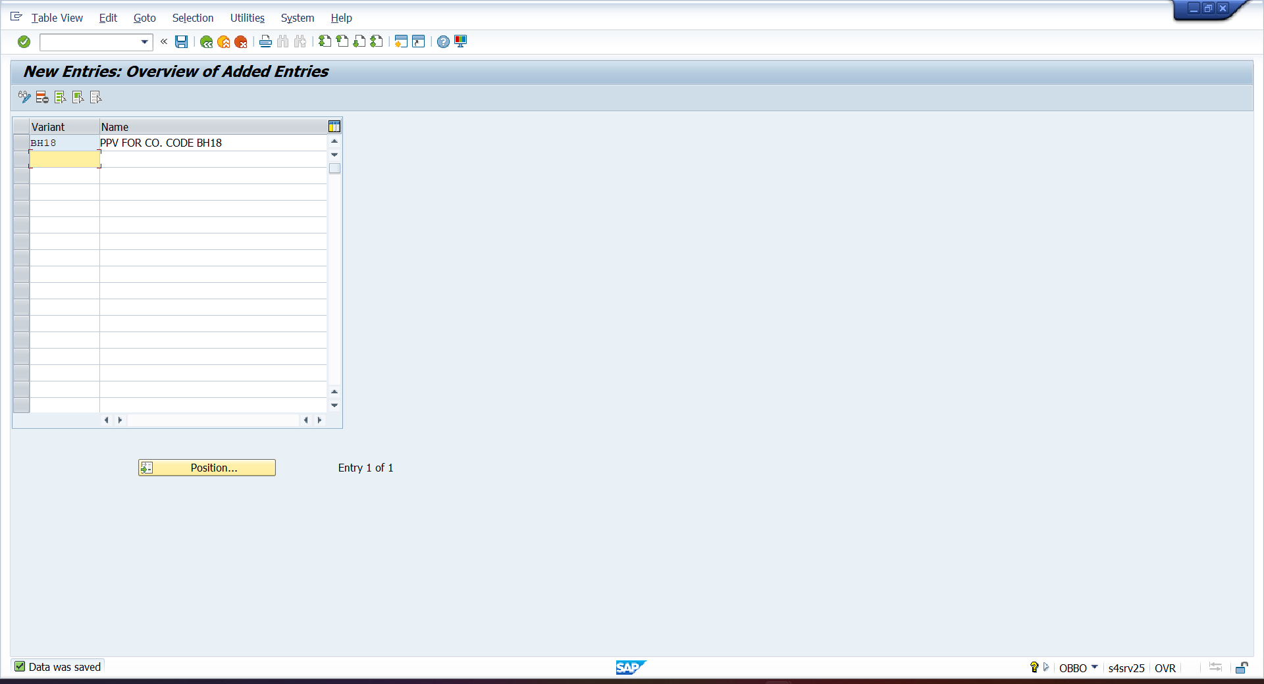

- OBBP – ASSIGN POST PERIOD VARIENT
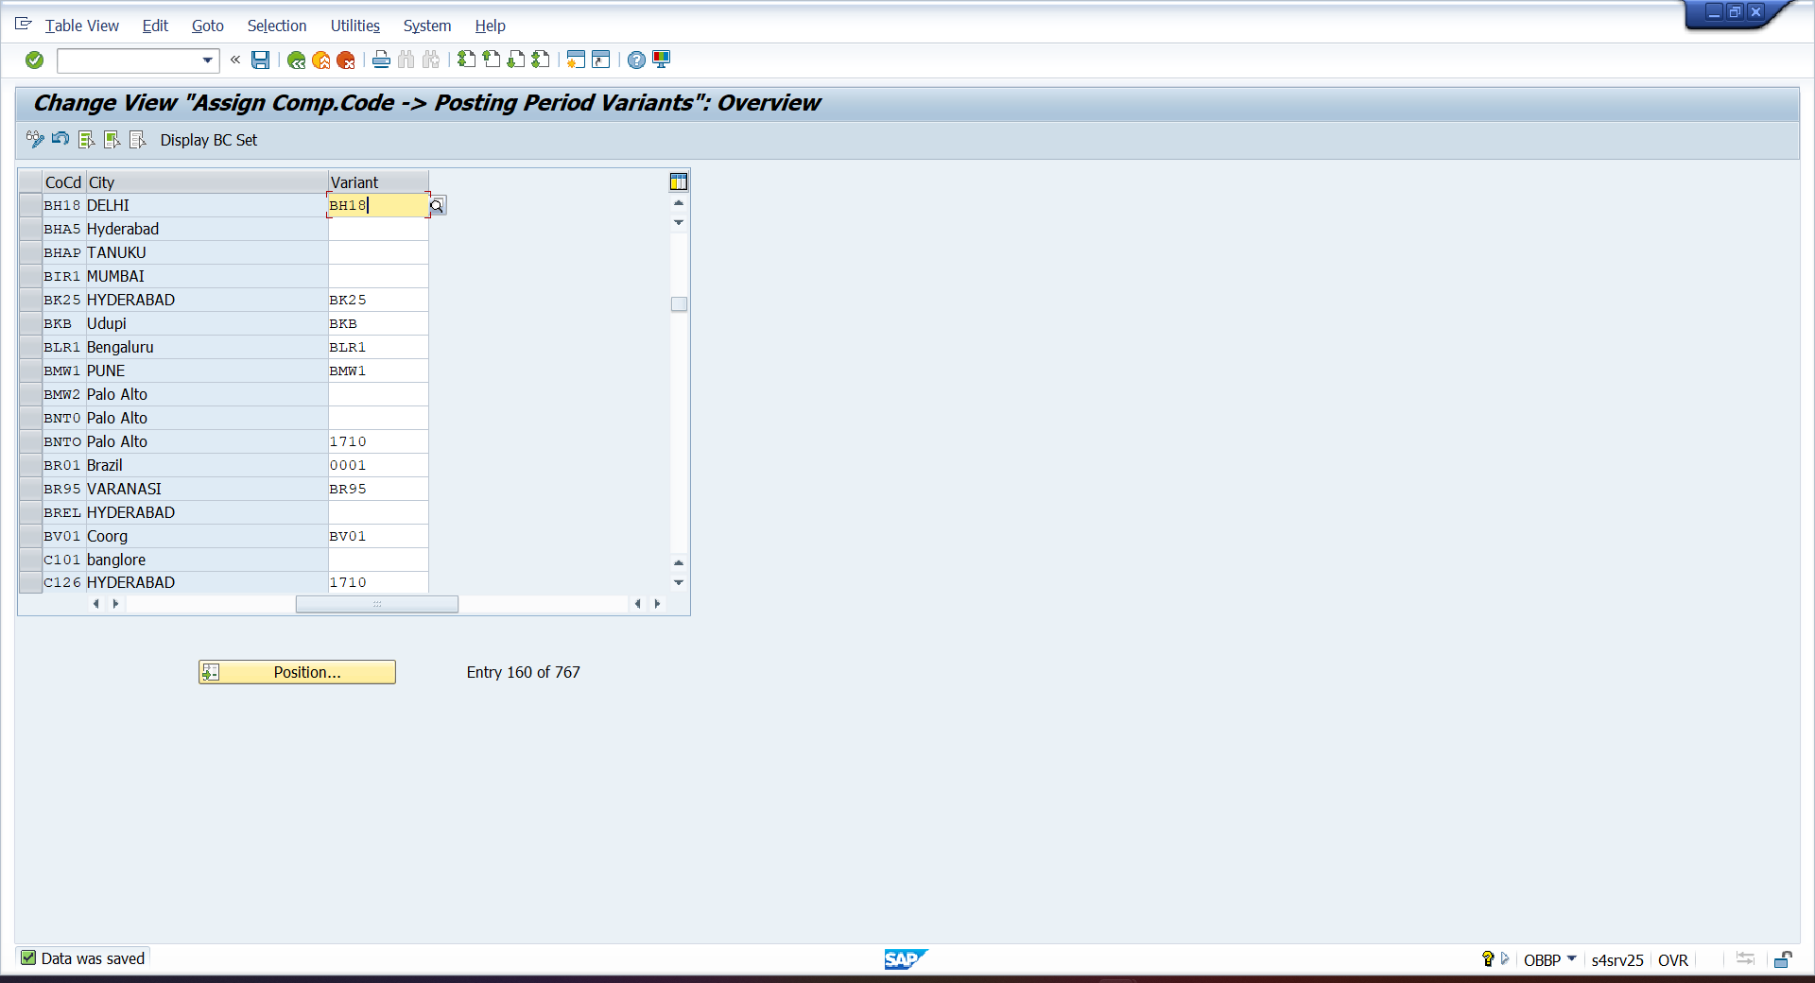
- OB52 – DEFINE POST PERIOD VARIENT
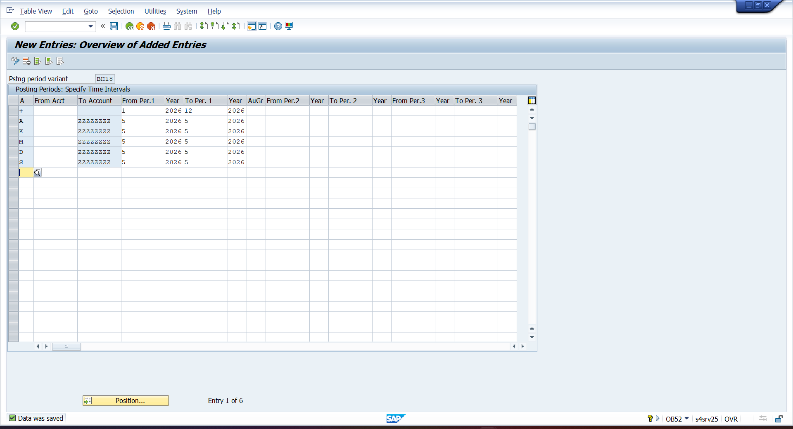

- OBC4 – DEFINE FISCAL YEAR VARIENT
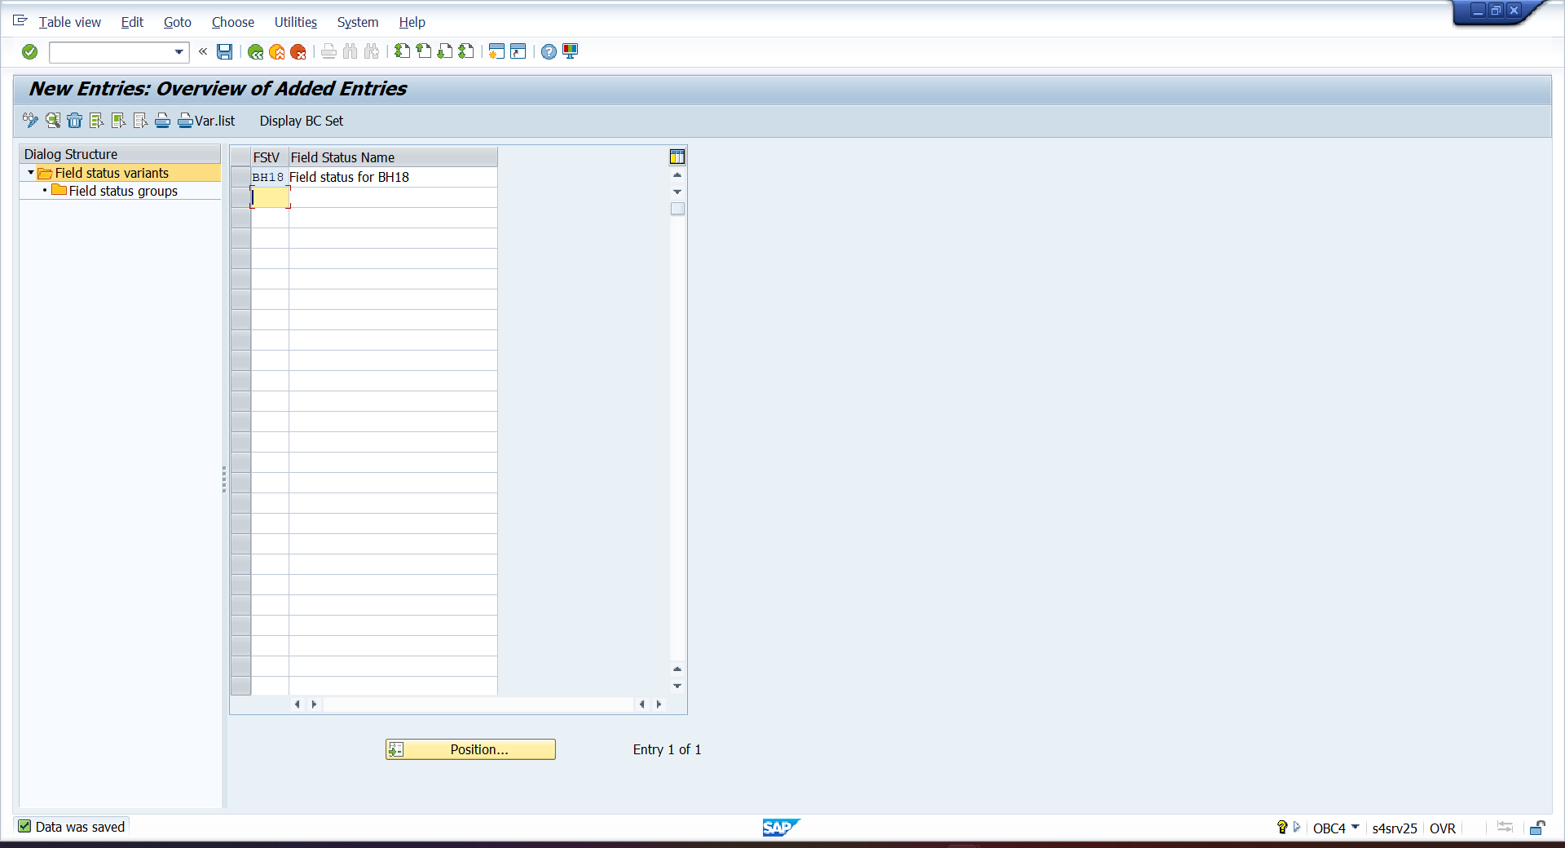

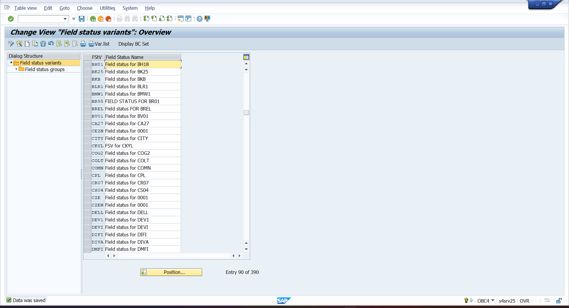

- OBC5 - ASSIGN FISCAL YEAR VARIENT
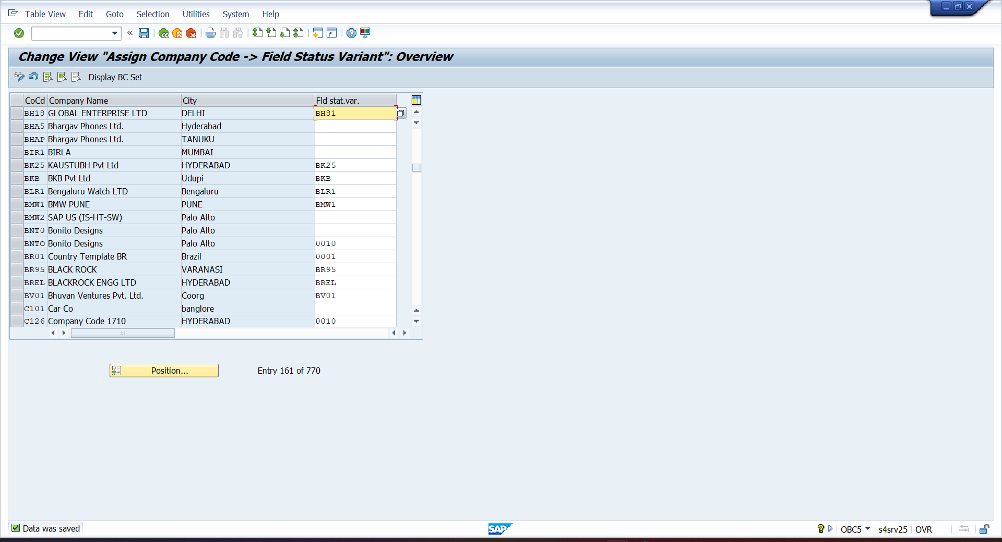

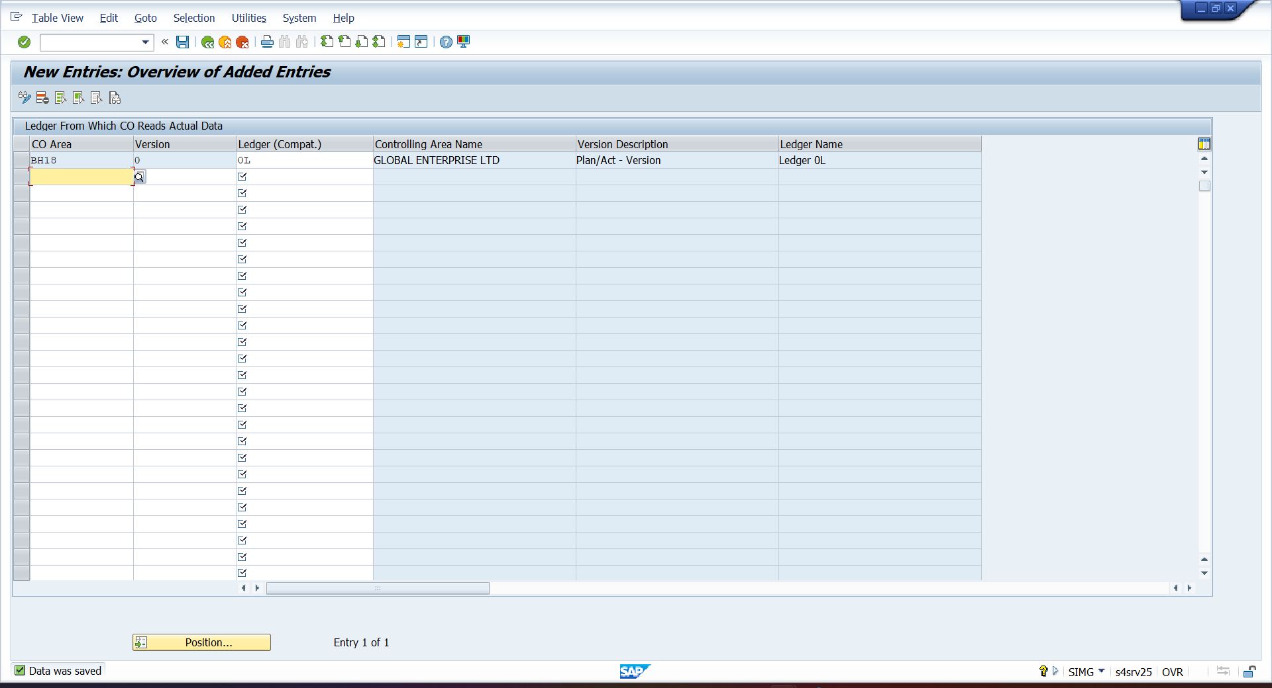

- OBA4 – TOLRANCE GROUP FOR EMPLOYEE
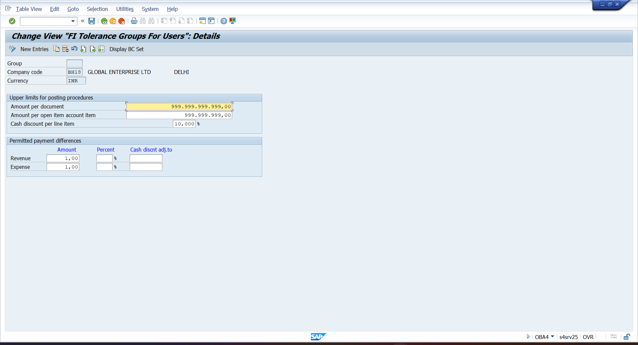

- OBAO – TOLRANCR GROUP FOR G/L GROUP
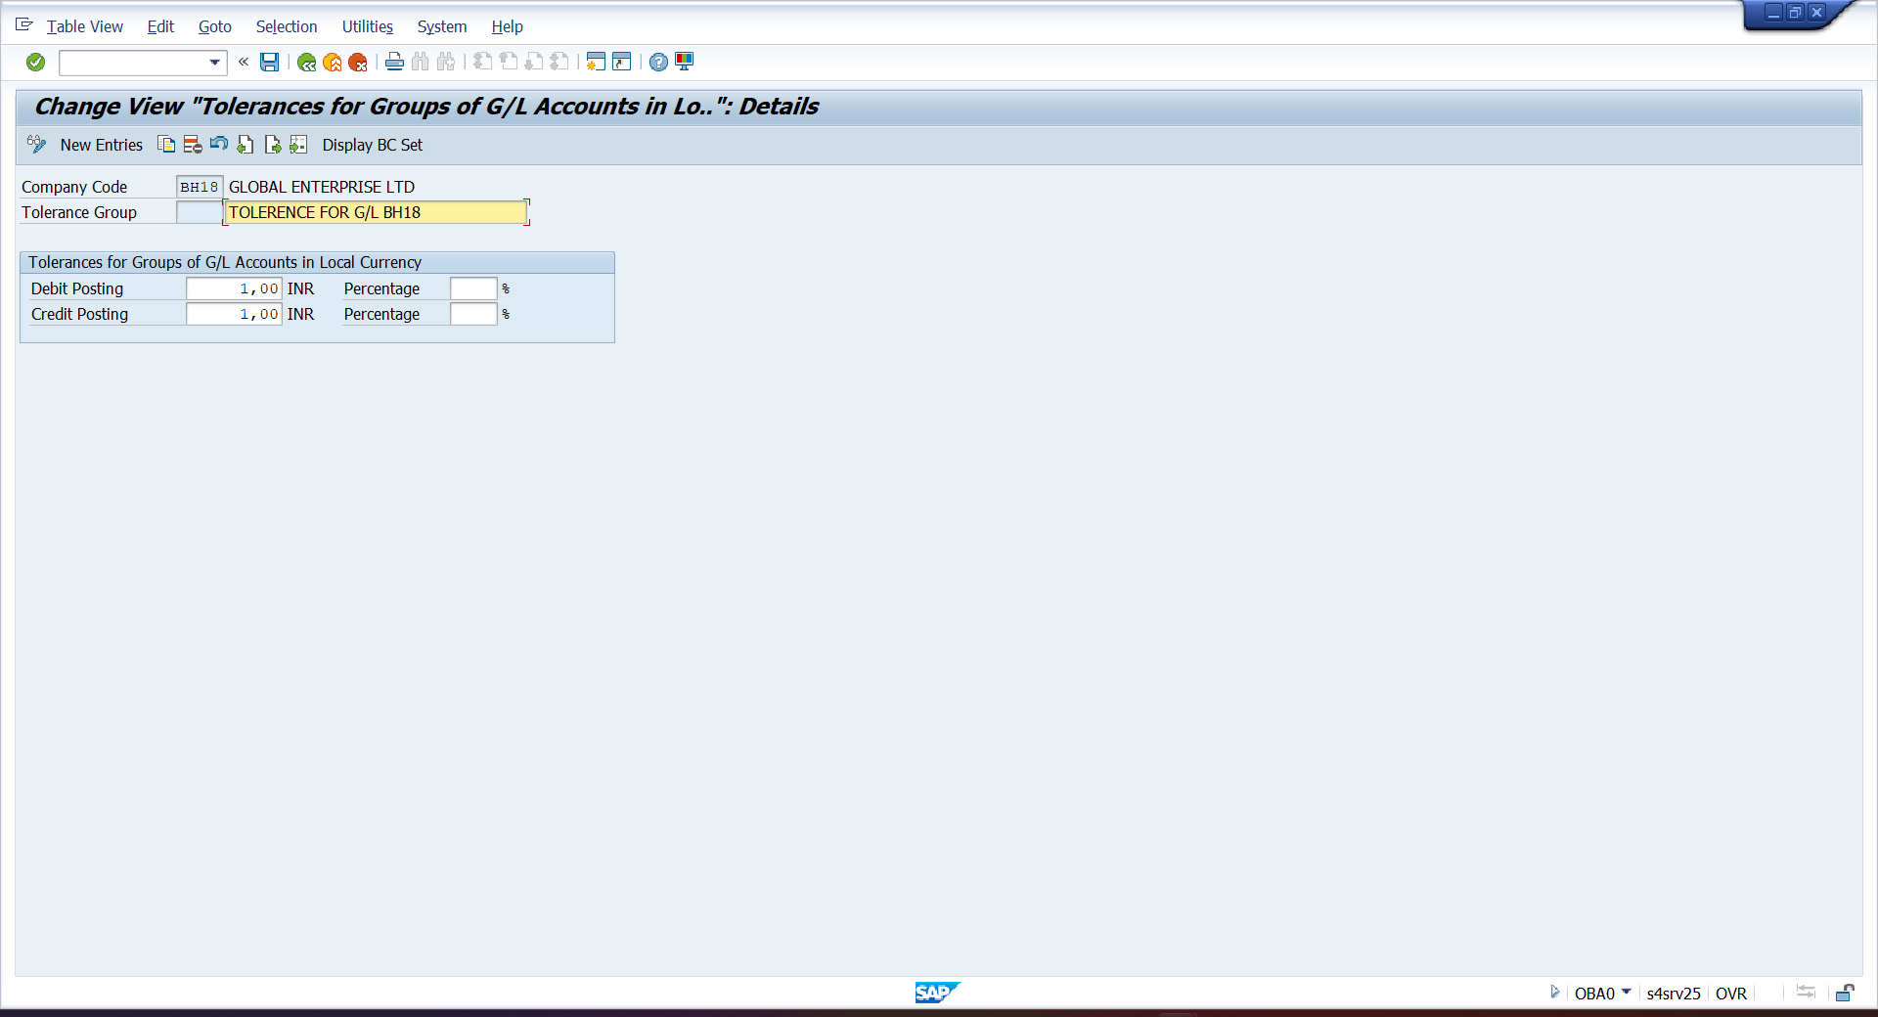

- FBN1 – ASSIGN NO. RANGES
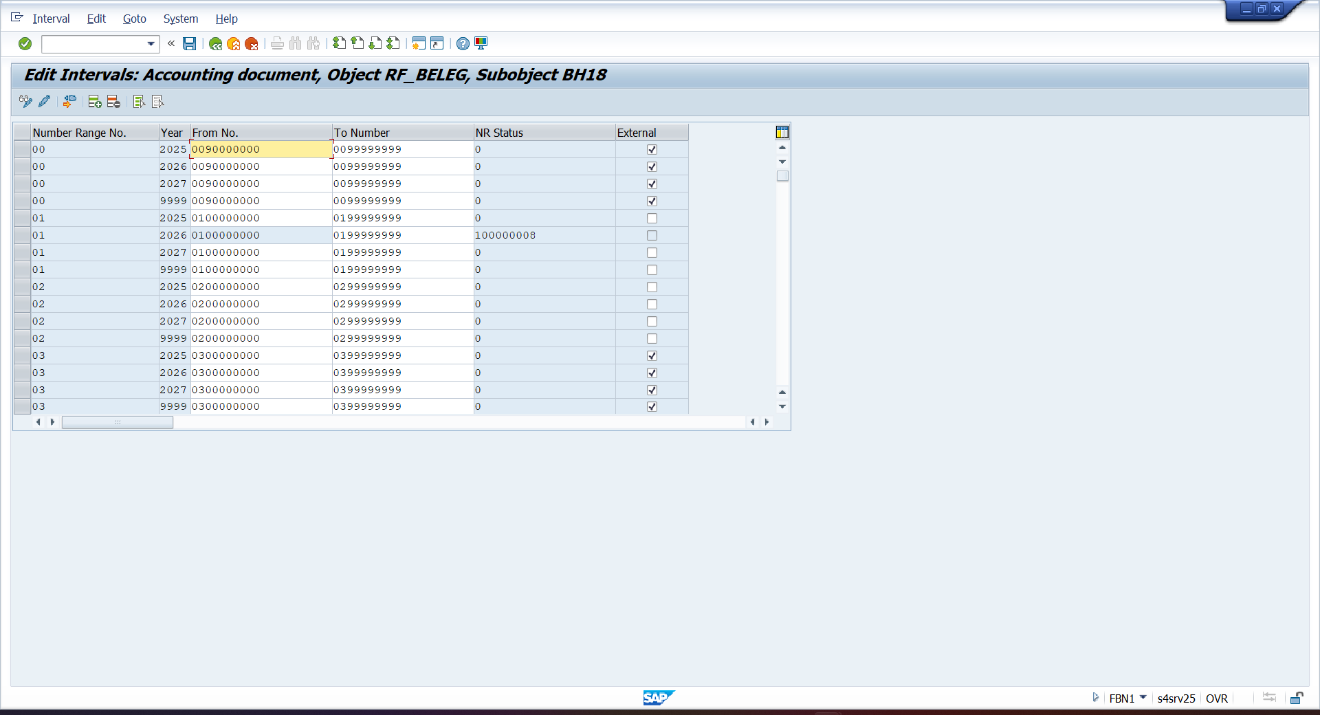

- FINSC_LEDGER – ASSIGN LEADING LEDGER
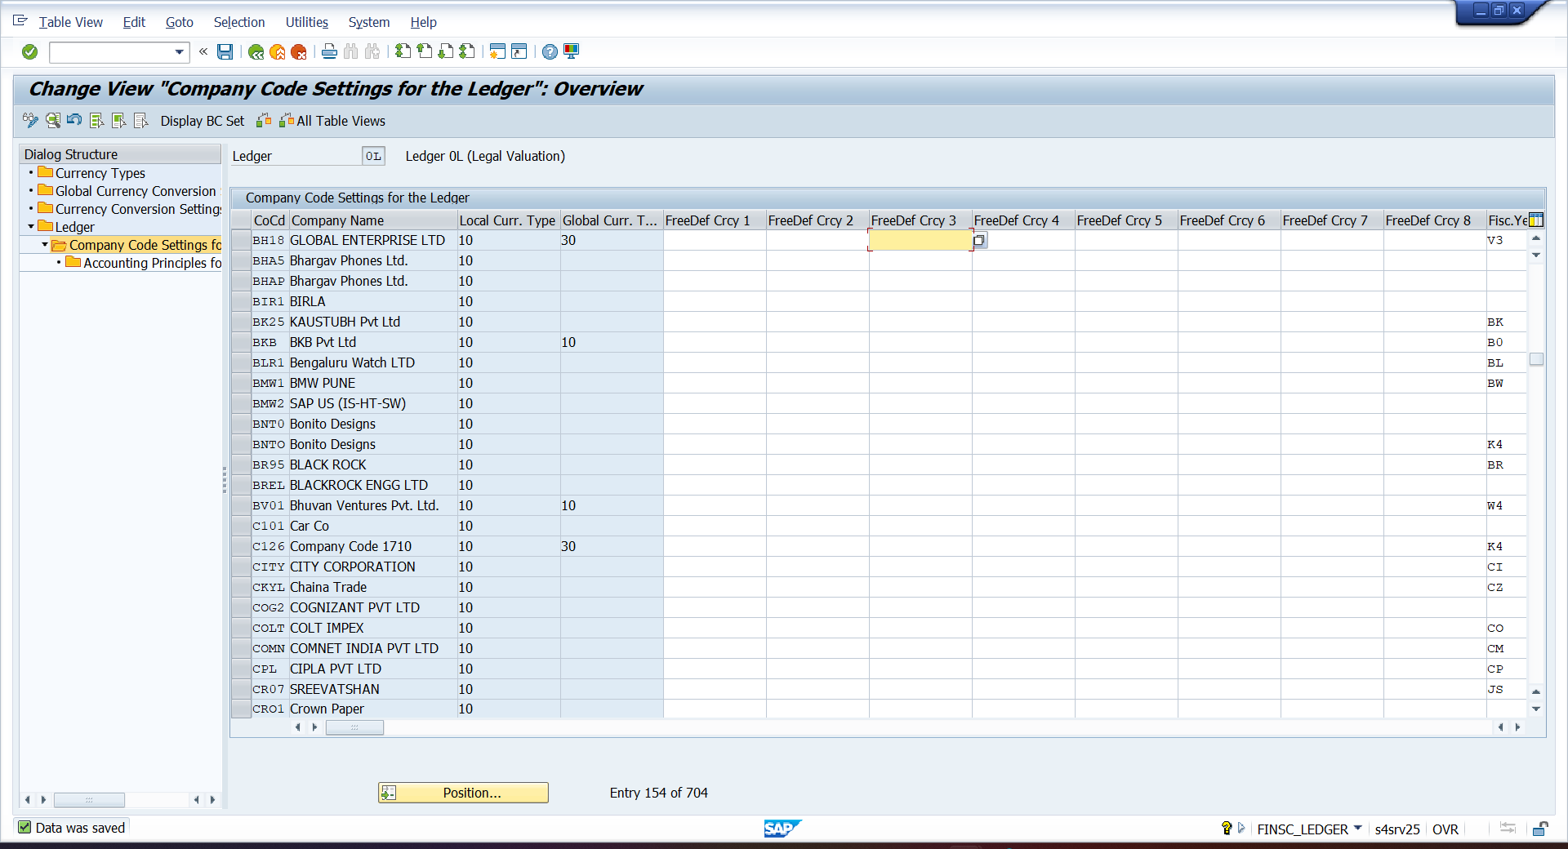

- OB13 – CREATE CHARTS OF ACCOUNT
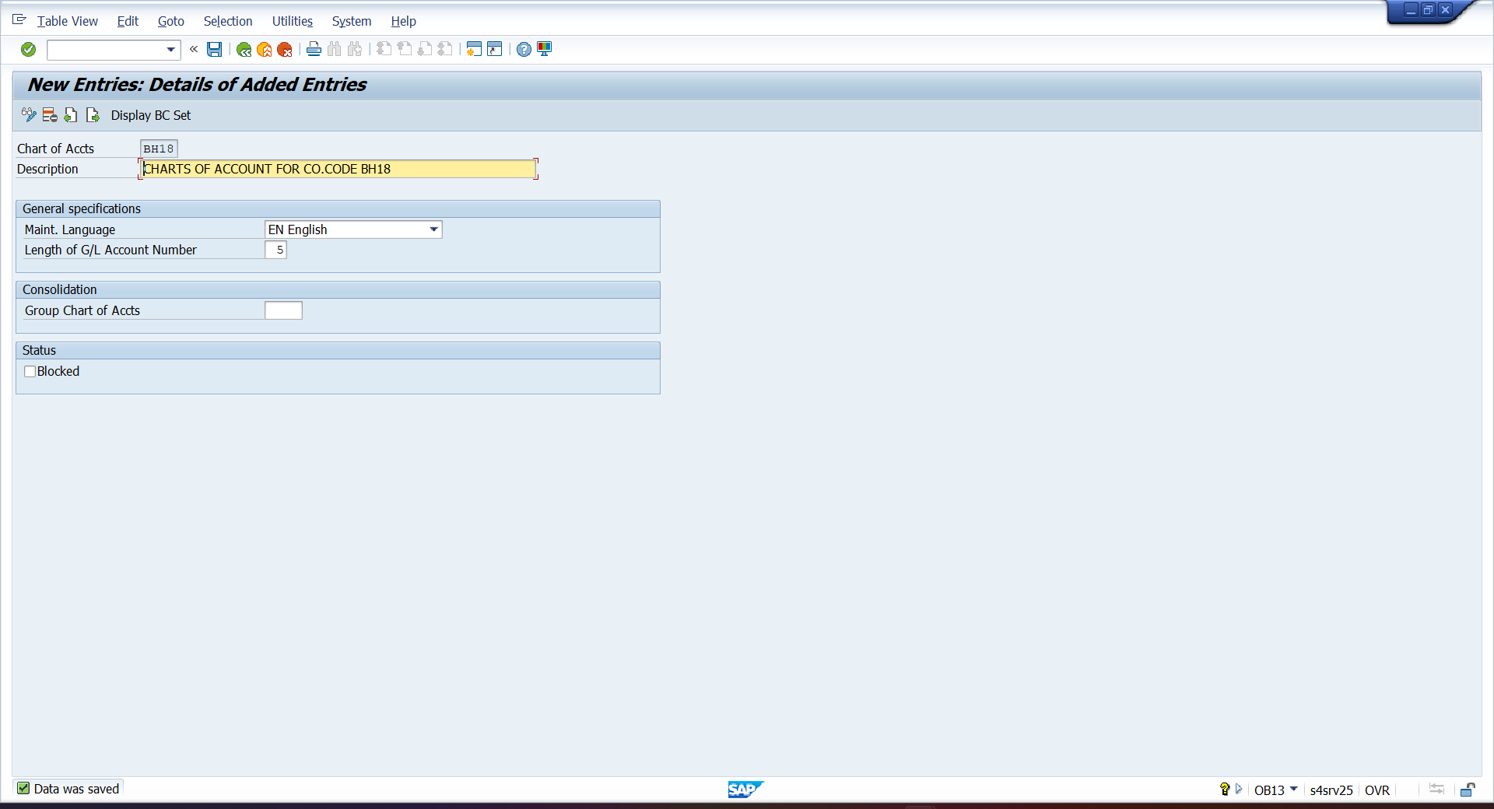
- OB62 – ASSIGN CHARTS OF ACCOUNT
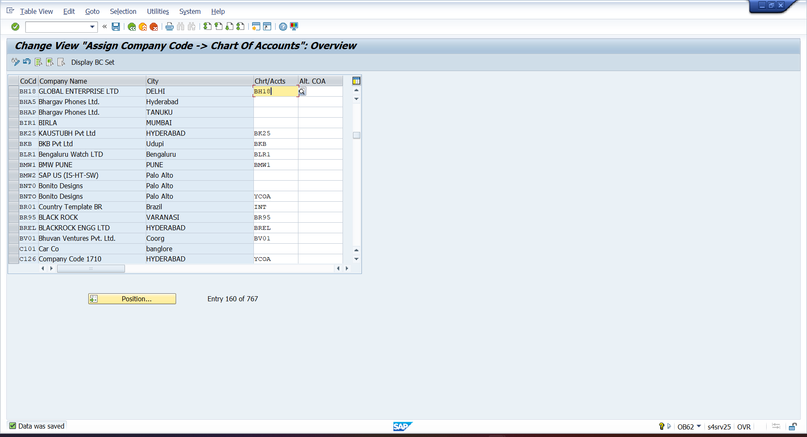
- OBD4 – MAINTAIN G/L GROUPING
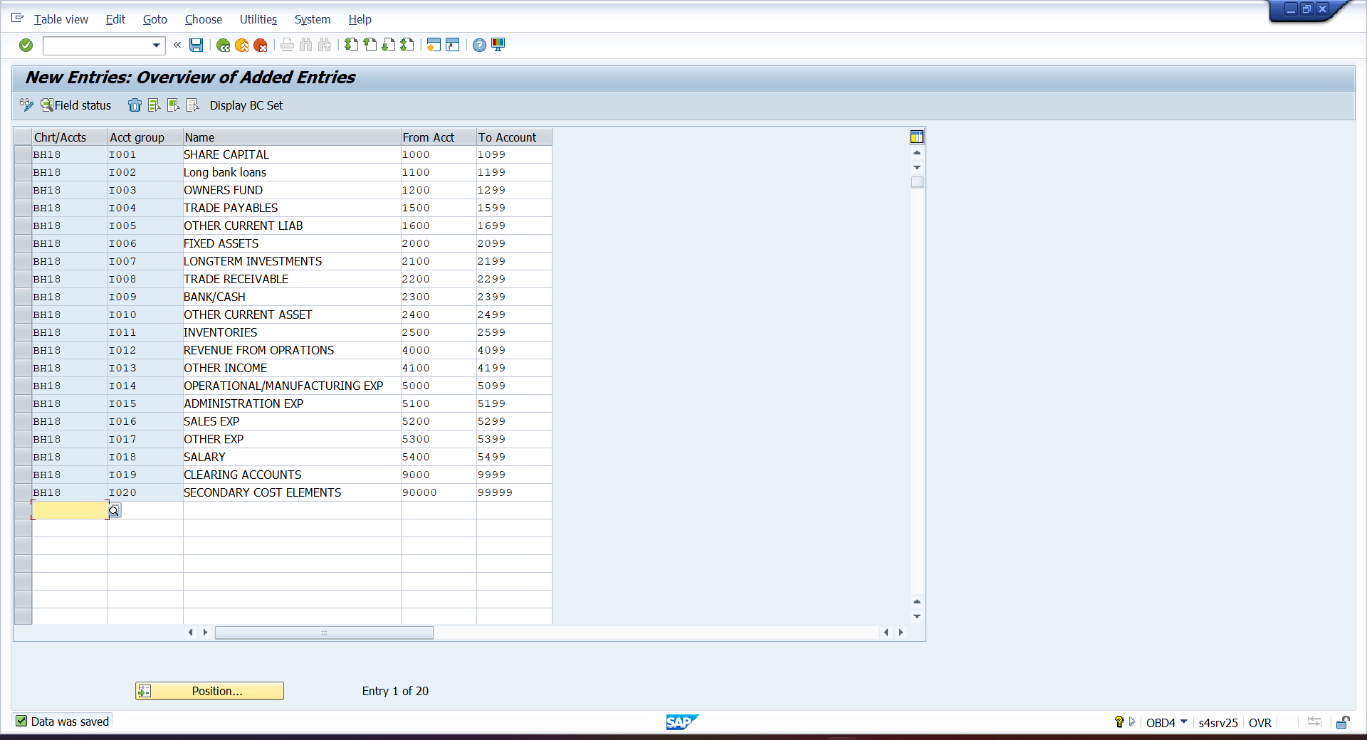

- OKKP – CREATE CONTROLLING AREA
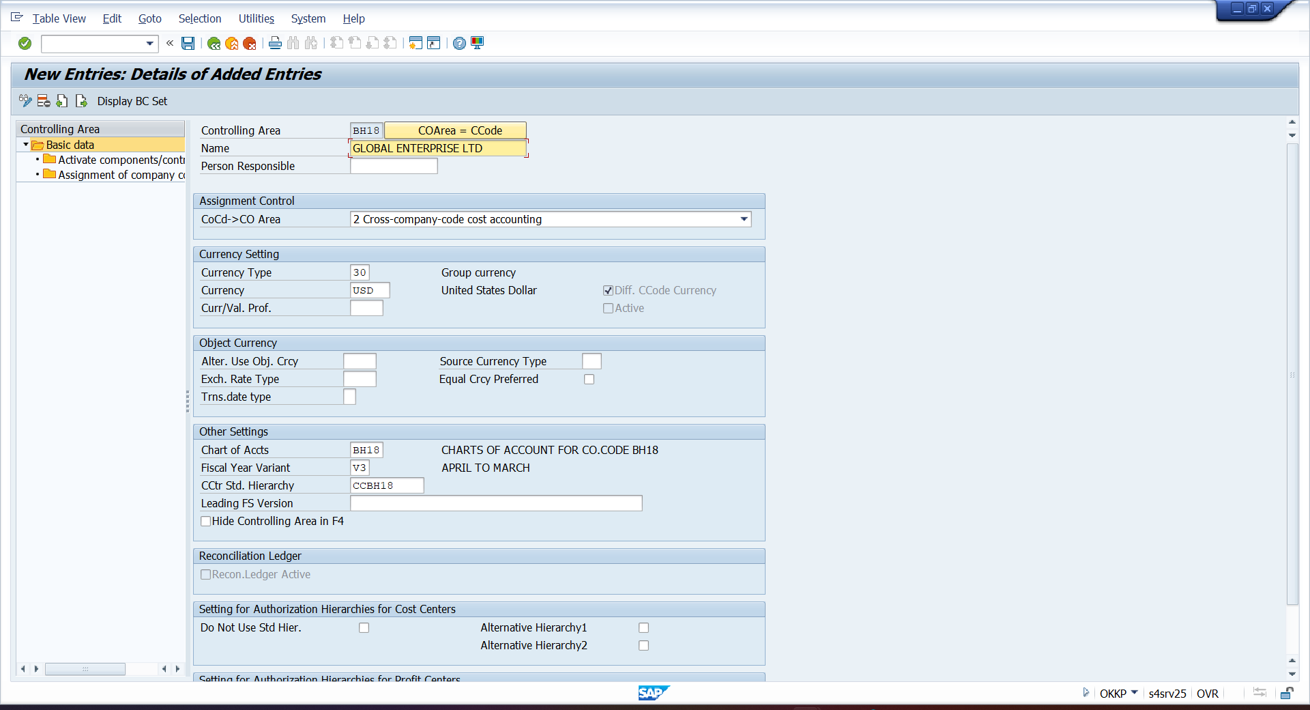

- ACTIVATE CONTROLLING AREA
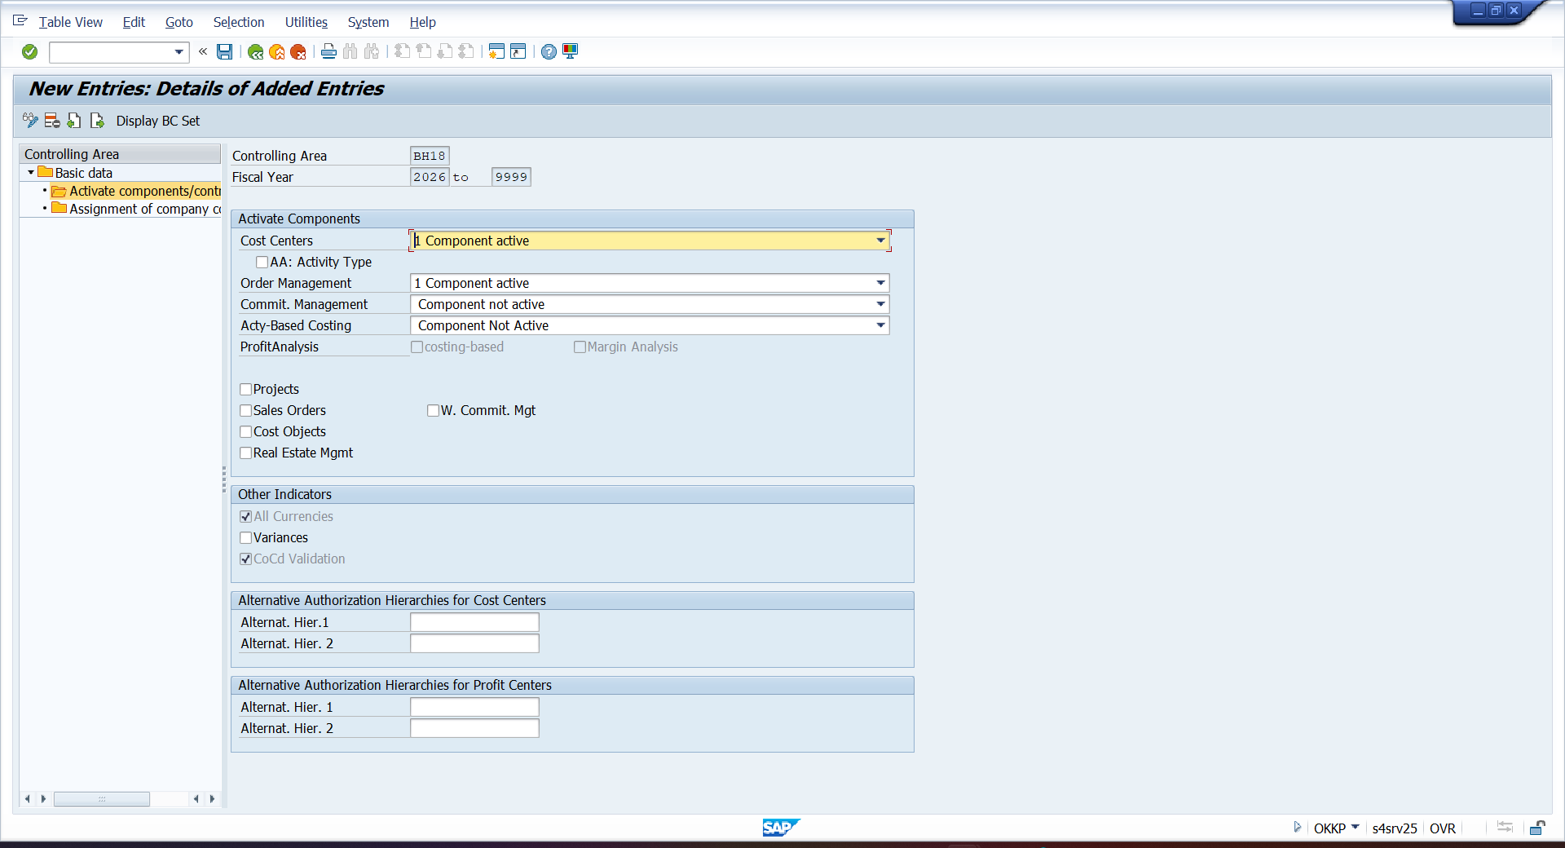

- ASSIGN CONTROLLING AREA
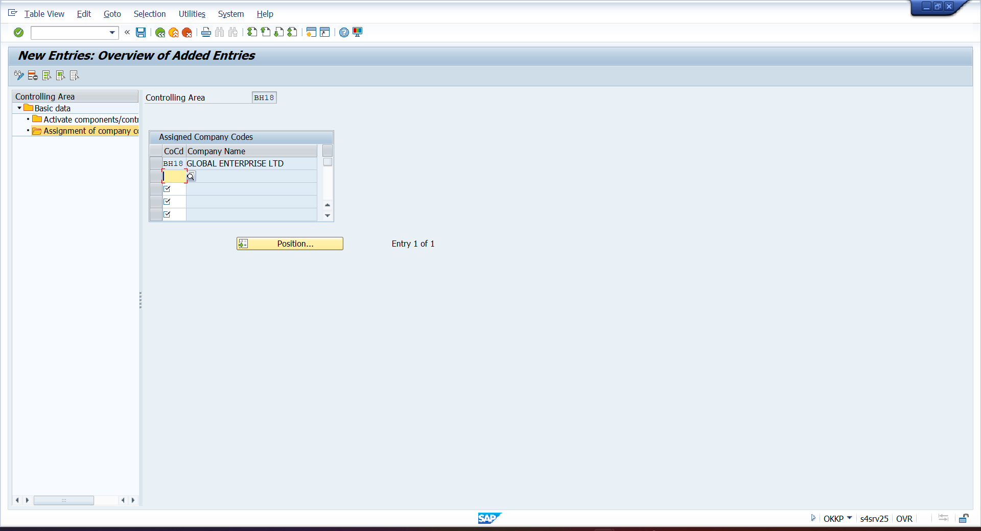
- OKEQ – MAINTAIN REPORTING VERSION
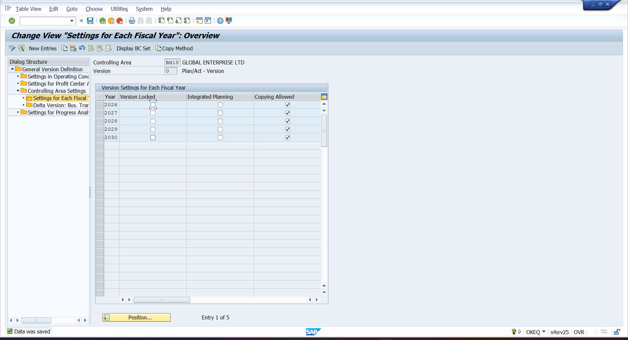
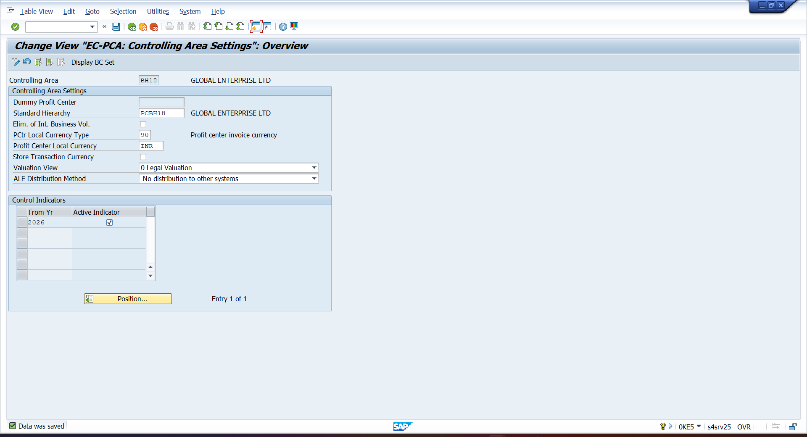
- 0KE5 – SETTING PROFIT CENTER

- IKEF – ACTIAVTE DIRECT POSTING
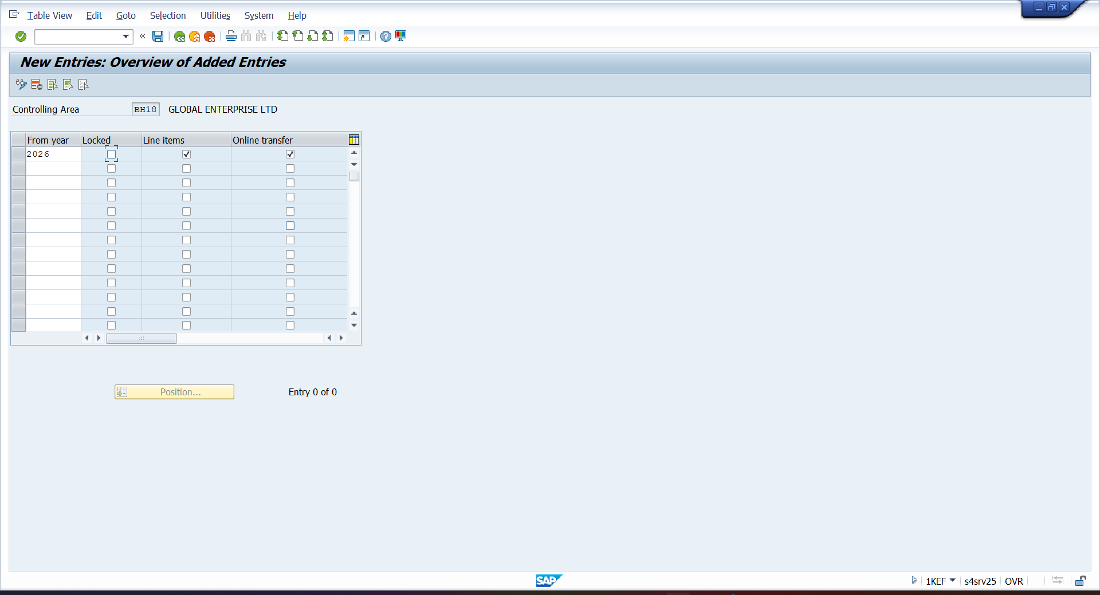

- KE59 – CREATE DUMMY PROFIT CENTER
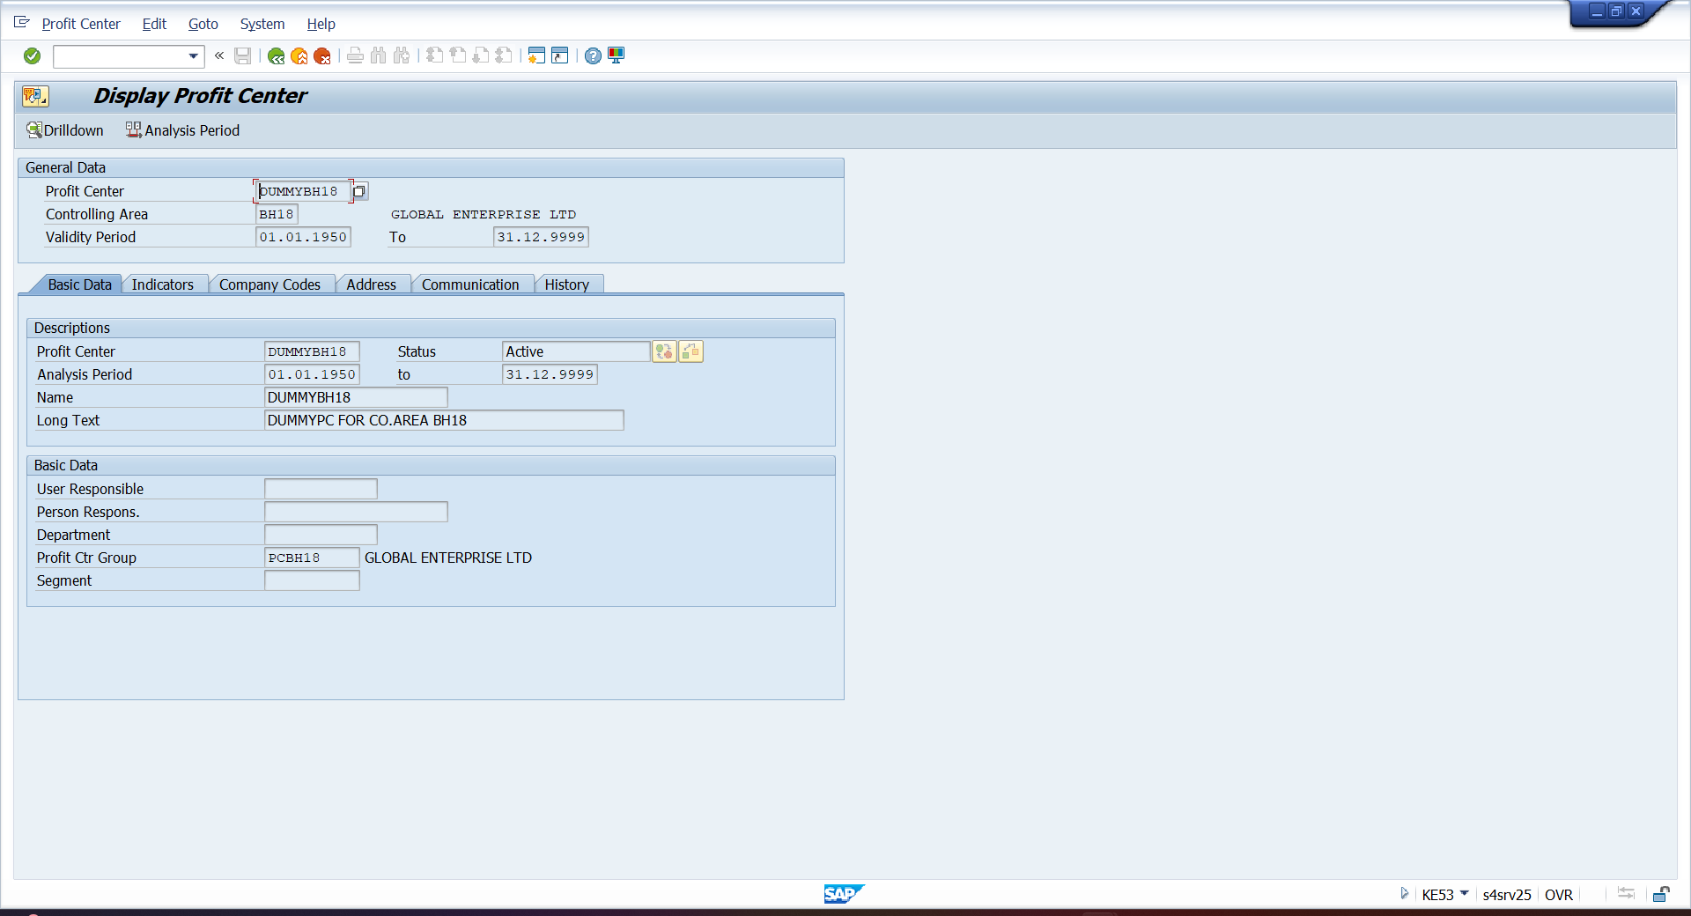

- KCH5N – CREATE PROFIT CENTER
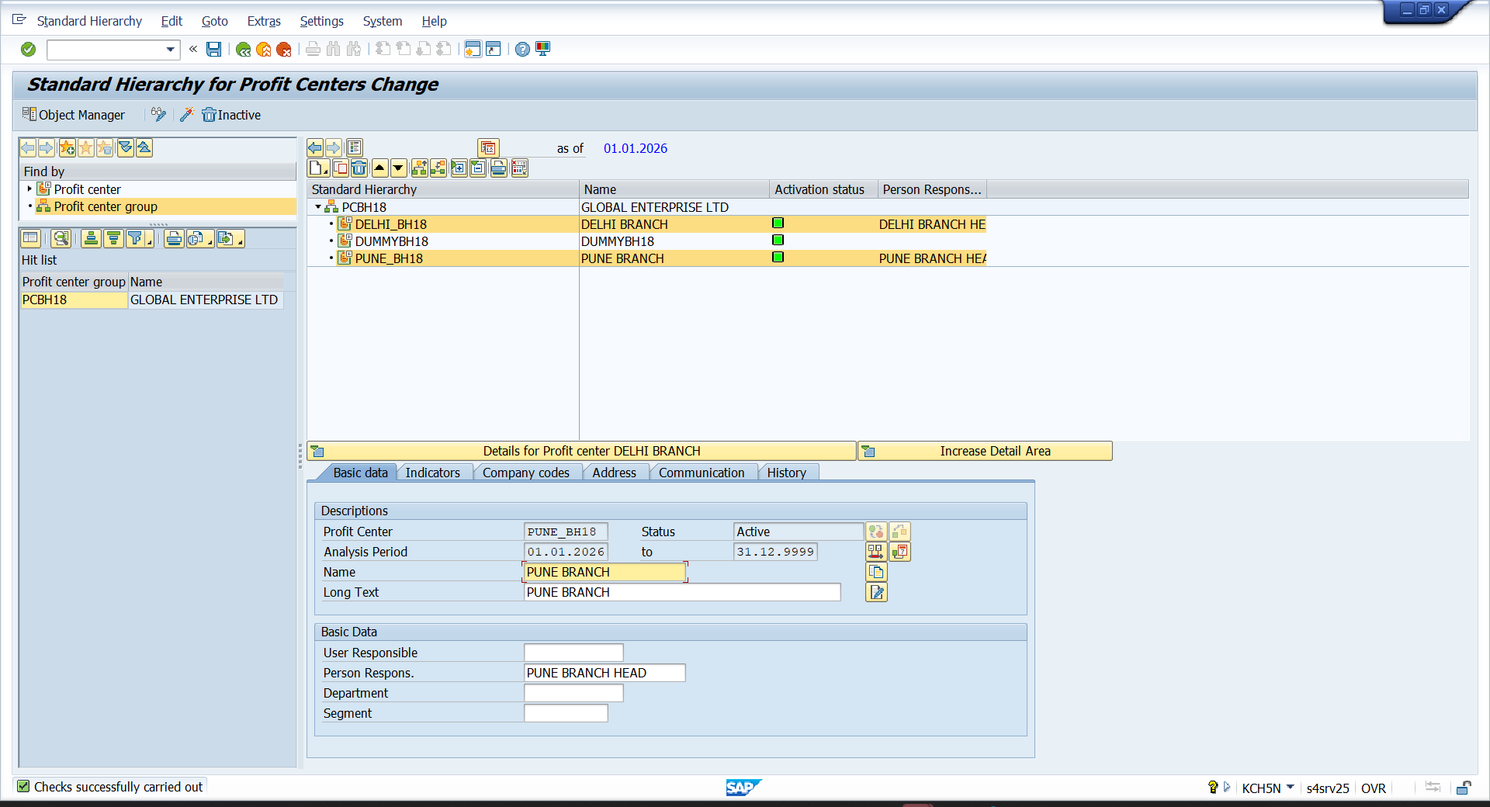

- OKEON- CREATE COST CENTER
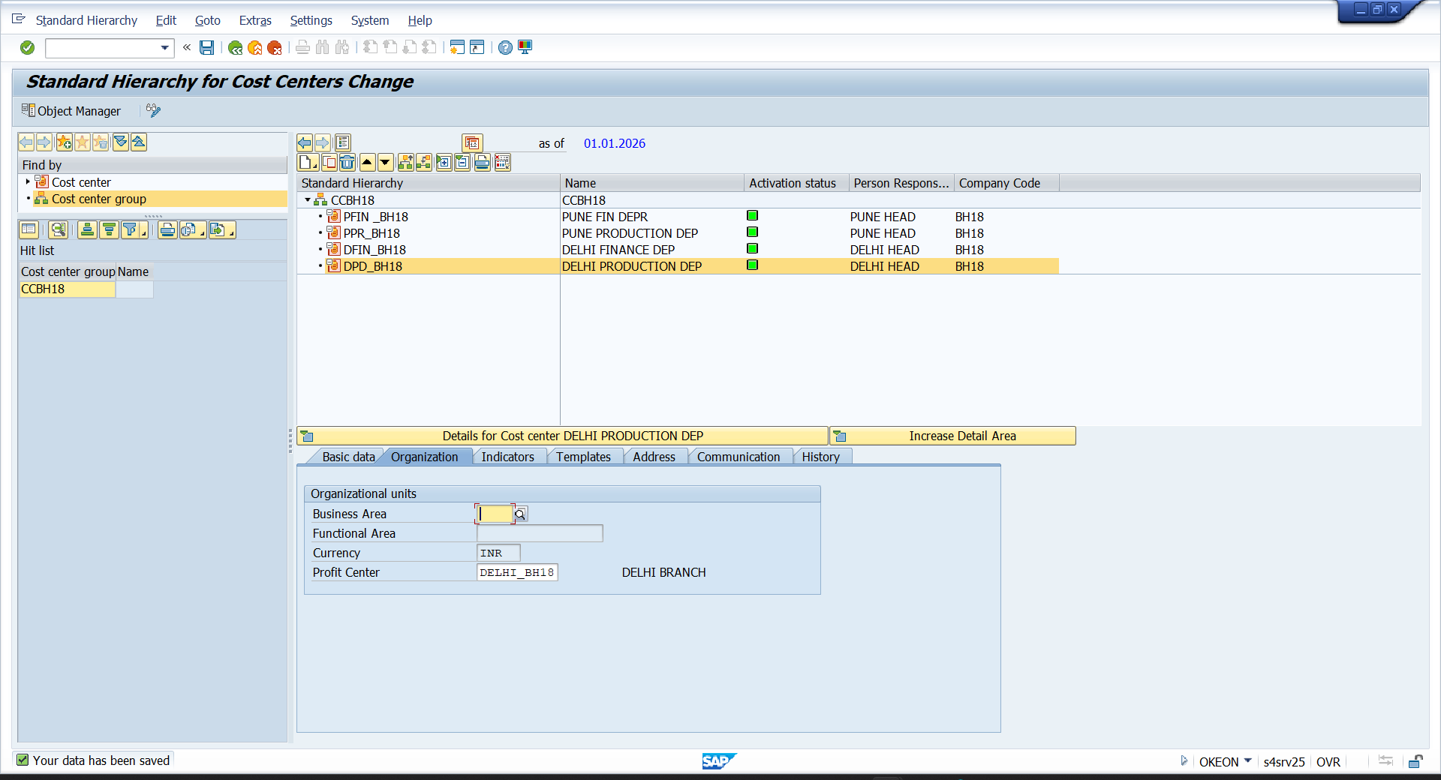

- DEATIVATE DOCUMENT SPLITTING
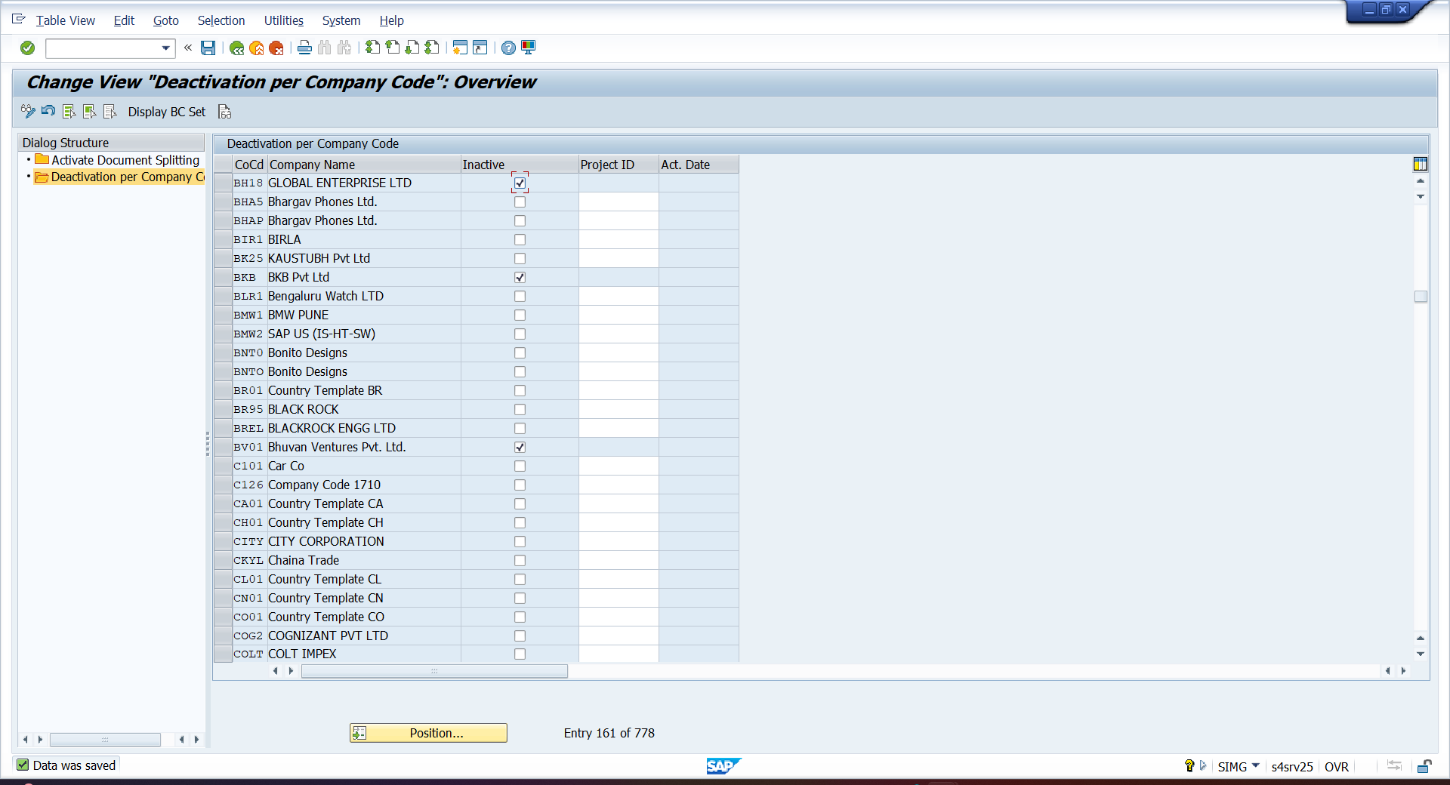

- FB50 – POSTING GENERAL ENTERY
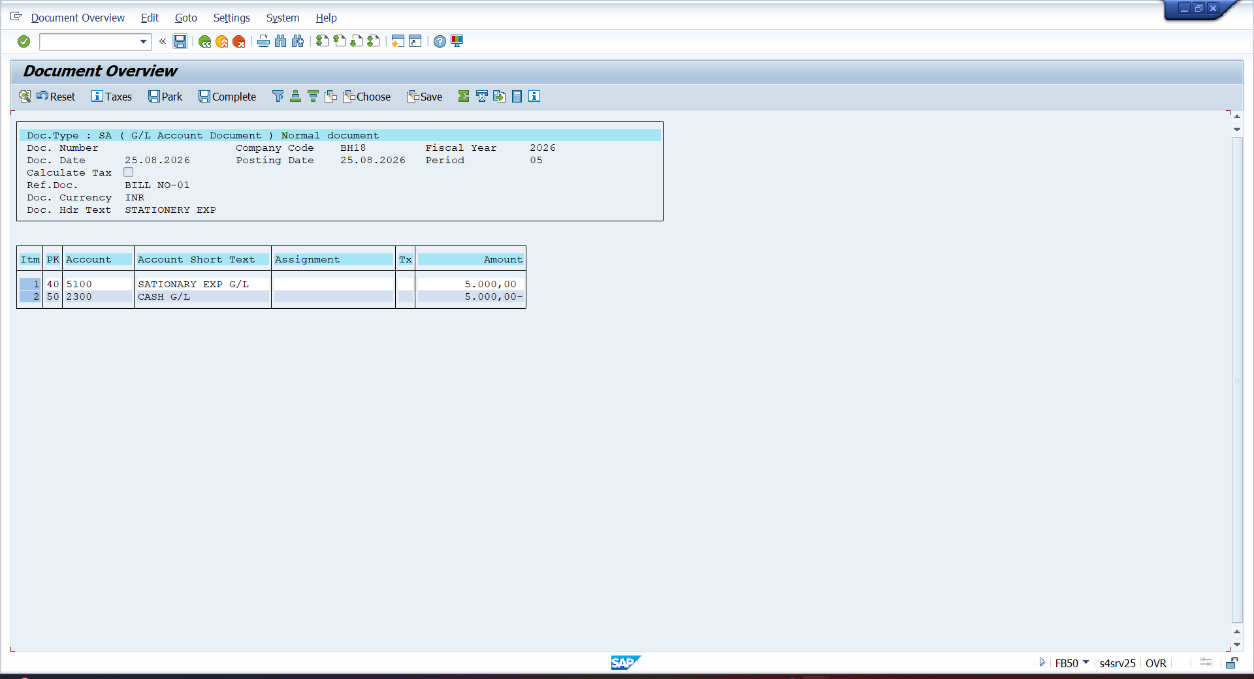

- SE16N – ENTRY IN UNIVERAL JOUNAL (ACDOCA)

